|  |  |
| --- | --- |
| **Working Paper 2014/xxx**  **Not for distribution – For peer review**  **purposes only** | **Document de travail 2014/xxx**  **Ne pas distribuer – Pour révision par les paires seulement** |
| Not to be cited without  Permission of the authors * | Ne pas citer sans  autorisation des auteurs * |

|  |  |
| --- | --- |
| **SCUBA** | **SCUBA** |

A. Rondeau, M. Comeau, and T. Surette

|  |  |
| --- | --- |
| Lobster Section  Gulf Fisheries Centre  Department of Fisheries and Oceans  P.O. Box 5030  Moncton (N.B.)  E1C 9B6 | Section du homard  Centre des Pêches du Golfe  Ministère des Pêches et des Océans  C. P. 5030  Moncton (N.-B.)  E1C 9B6 |

### SCUBA surveys

Visual line-transect surveys using SCUBA divers on lobster habitat between 2000 and 2012 were done to assess the lobster density at various sites in the sGSL (Table 7). The longest uninterrupted surveys have been carried out in Caraquet, located in sub-region 23BC, and Shediac (sub-region 25S) starting in 2003 and 2005, respectively. Other sites were selected and added from Pointe-Verte to Pictou Island to cover LFAs 23, 25 and 26A located in central Northumberland Strait, Some sites in NB and NS were originally selected to create nearshore artificial reefs to compensate for declared harmful alteration, disruption and destruction of marine coastal habitats (DFO, 2012) and the *in situ* site selection process and monitoring were coordinated or carried out by DFO Lobster Section, Moncton. Ultimately, several sites have been chosen as permanent sites (Table 7; Figure 101).

The main objective of the SCUBA survey design was to measure absolute lobster population density and sample length frequency. The survey design has three components. First, a selective design was used to draw a survey region, i.e., identifying lobster reefs, within the site. Then, line-transects within the survey region were placed using a haphazard design and, finally, a systematic design was used to survey the site on a yearly basis.

We used a two steps approach to draw the survey region that consisted of mapping and visual surveys. Mapping the location of lobster reefs was first done based on harvesters’ traditional fishing knowledge through interviews followed by mapping using the OLEX™ system. During the interviews, harvesters were asked to identify on a map their general fishing locations with rocky habitat characterized by gravel, cobbles and small boulders at depths ranging from 4.5 to 10.0 m. Also, some exclusion mapping was done where harvesters identified areas with soft sediments, i.e., undesirable survey locations. The actual seafloor mapping was done by remote sensing using an OLEX™ system. This system is connected to echosounders and analyze bottom echo, taking into account parameters such as pulse length, beam width and transducer type. A naturalized bottom backscatter is calculated and added to the internal chart where hardness is shown as adjustable colors for seafloor hardness. This system will allow for automatic seafloor mapping using bottom discrimination and hardness. This equipment is a high-speed plotter that used the echosounder depth data and GPS lat/long data to generate small scale topographic seafloor maps for large areas in real time. A single-beam (Simrad™ CM 60 and ES 60 complete system) was used between 2004 and 2007, and a multi-beam (WASP™ system) is now being used. The second step was groundthruting the mapping by carrying out visual surveys. These surveys were done on a flat bottom in water <10 m deep with gravel and cobble substrate either by an underwater camera deployed from the surface or SCUBA divers. During the visual survey, information was gathered on the abiotic (i.e., to corroborate the information from the remote technology) and biotic (i.e., density or presence of lobster, other benthic species and densities of the algae coverage) habitat characteristics for the final selection of the most appropriate survey region to set line-transects. Essentially, wide areas with dense algae cover (mainly kelp), large immovable boulders, stacked of smaller boulders, soft sediment bottom (i.e., mud and/or sand), or unbroken granite or sandstone sheet were avoided.

On selected survey regions (i.e., lobster reefs) within a site, leaded line-transects were placed haphazardly always parallel to the coastline to assist the diver movements (i.e., divers surveyed against the current to avoid low to nil visibility from disturbed silt while overturning small boulders). Start and finish positions of all line-transects were entered into the onboard GPS chart plotter and, if chosen for a given year, were systematically sampled. The number of line-transects per site was established based on the lobster reef size and the pre-approved diving time allowed for the site. Weather permitting, at least 3 line-transects per year on selected sites were sampled.

A 100-m leaded line-transect marked at 5-m intervals was used to survey all of the sites. Two divers descended and swam on either side of the line-transect. Each diver sampled on one side of the line-transect searching 2-m perpendicular to the line-transect along its entire length (100-m) for a total swept area of 400 m2. Our SCUBA survey was designed to meet underlying assumptions identified by Burnham et al. (1980) to achieve reliable estimates of population abundance from the line-transect sampling model. These four assumptions are: lobsters directly on the line will never be missed (i.e., they are seen with probability of 1); lobsters are fixed at the initial sighting position (i.e., they do not move before being detected and none are counted twice); distances are measured exactly, thus, neither measurement errors nor rounding errors occur; and finally sightings are independent events.

Divers attempted to capture every lobster observed within the line-transect. All captured lobsters were measured (CL) and the sex was determined. Beside lobster, divers also recorded the seafloor characteristics (i.e., size and aggregation of rocks and other substrate’s feature). The information from each diver was recorded on underwater sampling sheets for every 5-m interval, which is equivalent of sampling forty 10 m2 quadrats along the line-transect.

Information on the seafloor characteristics was used to gather knowledge on hard-bared or soft substrates (i.e., seafloor not considered as lobster habitat) and evaluate the sampling complexity within a line-transect. The sampling complexity refers to the ability of a diver to efficiently sample a 10 m2 quadrat. To standardize the information collected by divers, the basic sediment size classification developed by Wentworth (1922) and later modified by Pettijohn (1949) was used. Sampling complexity was identified as simple if a diver could sample a quadrat without missing or underestimating the presence of lobsters and complex if unable to do so. The complexity of the habitat within a quadrat was assessed based of the assemblage of different type of rocks and macro-algae within the quadrat. Based on assumption 1, quadrats (10 m2) that were identified as complex by divers within each transect line were removed from the analysis. Also, quadrats with soft substrates (i.e., mud and sand) or solid sheet of sandstone and/or granite with no ledge (referred as hard-bared seafloor) were removed from the analysis because they were not considered lobster habitat. SCUBA data were analyzed to derive both abundance and production indicators.

### Lobster abundance – SCUBA

The goal of the this analysis is to provide a synthesis of SCUBA data collected since 2000 in various sites in the sGSL, with special focus on spatial and temporal trends in abundance and relative scaling between cohorts,. For each transect (*n* = 724), counts of observed lobster by cohort, using size intervals based on Hudon (1987) and Gendron and Sainte-Marie (2006) (Table 9), were tabulated and analyzed.

A generalized linear mixed model (GLMM) was used, which assumes that observed counts are realizations from a Poisson whose conditional mean is defined by an log-linear 3-factor (i.e., year, site and cohort) additive model with full interactions (Jiang 2007).

Formally, the model may be written as:





where  is the observed count for transect *i*, year *j*, site *k* and cohort *l*,  the Poisson mean, is a global intercept term,  are year effects,  are site effects,  are cohort effects,  are year-site interaction effects,  are year-cohort interaction effects,  are site-cohort interaction effects,  is a year-site-cohort three-way interaction effect and  is an observation-level random effect to account for over-dispersion. We formulated a full Bayesian model (Gelman, 2004) by specifying priors for each parameter. The intercept term was assigned an uninformative prior of . Random effects were drawn from normal distributions with zero mean and variances drawn from an uninformative gamma prior, one for each additive and interaction term. An offset term  was included in the linear term, where  is the surface area of each transect, in order to standardize the means to a standard transect surface area of 100 m2. Inference on posterior distributions was performed via MCMC sampling using OpenBUGS (Lunn et al. 2000, 2009).

The hierarchical structure of the model provides a relatively simple way of pooling information between years, sites and cohorts. Interaction terms allow for variation between temporal, spatial and cohort trends to be incorporated in the model. This combination of hierarchical pooling and model flexibility allows us to make reasonable inferences on missing data observations, all while taking uncertainty into account.

Once we have a set of inferred mean densities, we then calculate a set of values, labelled *R,* which correspond to relative differences between cohort means from adjacent years. On the log-scale these are defined as:



where  is the marginal mean for year *j*, site *k* and cohort *l*, while  is the marginal mean for previous cohort in the previous year. On the regular scale, the relative change is given by . A value of  of one (i.e., a  of zero) corresponds to no change between cohorts from adjacent years. A  value greater than one implies an increase while a  value less than one implies a decrease. Marginal posterior values for *R* were obtained by averaging over the appropriate dimensions (i.e., over years, sites or cohorts). Given that *R* is defined as a difference between terms, we could have formulated our model as a cohort-structured population model, expressing cohort means as a function of *R* values rather than its reciprocal. However, the focus here is to explore the structure of *R* values rather than impose a priori structural constraints upon it. Future versions of the model, within which constraints on *R* may be applied, could be expressed in a cohort-structured form more familiar to population biologists and discussions from this analysis will form the basis for future development of a population model.

Note that uncertainty due to missing data and sampling intensity are all taken into account by this type of model, and this uncertainty is contained in all inferences regarding *R* values.

### SCUBA and lobster settlement index

Three production indicators were derived from data collected from SCUBA surveys and bio-collectors. For the SCUBA production index, the standardized empirical mean number of berried females observed during SCUBA surveys from Caraquet was used. To assess the potential contribution of MLS increases to egg production, the proportion of berried females ranging in size from 70 to 75 mm CL between 2007 and 2012 was used. This time period was used because of the steady increase of the MLS by 1 mm per year in LFA 23B (Table 4). For the recruitment to the benthic habitat index based on SCUBA data, standardized mean number of lobsters derived from the Bayesian model (3.1.4) and empirical data were used for the 1-year old benthic animals (cohort 1) from various sites (Table 7; Figure 101).

A lobster settlement index was derived from bio-collector data. Lobster observed in collectors may be grouped into two categories: smaller-sized young-of-year (yoy) lobsters (the category of interest) and larger-sized lobster called walk-ins. The former is from the direct settlement of larvae into the collector while the latter is from individuals that had settled in previous years in the surrounding substrate. Because of the interplay between molt schedule and the timing of the observations, a gap is usually apparent in size-frequency histograms at around the 14 mm CL (Figure 102). We used this feature to derive a classification rule, for separating individuals based on size for each year and site. Hence, a mixture of two normal distributions was fit for each unique combination of year and sampling site. Using a Bayesian approach, hierarchical priors were placed on the mixture proportions as well as the means. Component variances were assumed to be common across year and site. Formally,

$$x_{ijk} |{ z}_{ijk}=0 \sim N\left({ μ_{ij}^{0}}_{,}σ_{0}^{2}\right)$$

$$x_{ijk} |{ z}_{ijk}=1 \sim N({μ_{ij}^{1}}_{,}σ_{1}^{2})$$

$$z_{ijk }\sim Bern(π_{ij})$$

where $i$, $j$, and $k$ are indices for year, site and lobster, respectively. The latent variable $z_{ijk }$ indicates the group to which the observed size $x_{ijk }$ belongs, $μ_{ij}^{0}$ and $μ_{ij}^{1}$ are the means of the yoy and walk-in groups, and the corresponding variances are $σ_{0}^{2}$ and $σ_{1}^{2}$, respectively. Assigned variance priors were $σ_{0}^{2} \sim Gam({10}^{-3}, {10}^{-3})$ and $σ_{1}^{2} \sim Gam({10}^{-3}, {10}^{-3})$, mean priors were $μ_{ij}^{0} \sim N(μ_{h}, σ_{h0}^{2})$ and $μ_{ij}^{1} \sim N(μ_{h}+θ, σ_{h1}^{2})$, where $σ_{h0}^{2} \sim Gam\left({10}^{-3}, {10}^{-3}\right)$, $σ_{h0}^{2} \sim Gam\left({10}^{-3}, {10}^{-3}\right)$ and $θ \sim U(0, 100)$, and the group proportion priors $π_{ij} \sim Beta(a,b)$, where $a \sim Exp\left(10\right)$ and $b \sim Exp\left(10\right).$

Once the model was fit, the classification rule was defined as the size at which the probability densities of each component were equal, under the assumption that each component had the same proportion. Lobsters smaller than this size were classified as being a yoy. Posterior samples of quantities of interest were drawn using MCMC sampling using OpenBUGS (Lunn et al. 2000, Lunn et al. 2009). Posterior predictions of the classification rule are presented in Table 8.

For the lobster settlement index, observed yoy counts per bio-collector were modeled as a Poisson distribution and estimated mean confidence intervals (at 95% coverage) were calculated by site and year. Estimations were performed using the *predict* function from the *stats* package in R (R Core Team, 2012). Means were scaled to a standard surface area of one square meter.

For all sites, the yearly accumulated degree-day (ADD) was calculated using the following equation (Dobson and Petrie, 1985):

ADD= $\sum{\left(T-T_{ref}\right) ×Time}$,

where, $T$ is the mean daily temperature, $T_{ref}$ is the reference temperature , and $Time$ is an index of day. A $T_{ref}$ of 12°C was used as a baseline and provides information on the level of thermal energy needed for lobster settlement (Annis 2005). For each site, the ADDs were calculated from 15 July to 20 September for each of the yearly temperature profiles available.

# RESULTS

### 4.1.5 Lobster abundance – SCUBA surveys

Based on the Bayesian estimation model, the standardized lobster abundance of all size groups from the SCUBA surveys in the sGSL increased steadily and significantly between 2000 and 2012 (Figure 103). The mean abundance (hereafter the lobster abundance for SCUBA surveys will be in number of lobsters per 100 m2) increased more than 5.4-fold, from 0.7 to 3.8 between 2000 and 2012. Spatially, differences were observed among sites along the north to south axis, reflecting a separation of lobster abundances within and outside central Northumberland Strait. Higher abundances (2.1-4.2) were observed in LFA 23 and sub-region 25N, while abundances in sub-regions 25S and 26AD ranged between 0.1 and 1.3 (Figure 104). Fox Harbour (at the LFA 25-26A boundary in central Northumberland Strait) had the lowest abundance at 0.1. In general terms, small lobsters seemed to be the driving factor for both the temporal and spatial trends. The contribution of cohorts 1 and 2 was significantly higher (Figure 105) compared to cohorts 3 to 6+ (cohort 0 will be discussed latter). However, spatio-temporal patterns in cohort abundance are often clearer if we focus on the ratios between cohorts, i.e., *R* or *R\**.

*R* values cannot be interpreted as mortality rates. Specifically, *R\** values (i.e., relative to 1) are ratios between cohort means, and are a confounding of sampling detection, natural mortality, fishing mortality and spatial dynamics. However, meaningful inferences on individual component processes of *R* may often be made, given that these are often cohort-specific. Mean values of *R\** >1 indicate an increase of lobster abundance compared to the previous cohort, while mean values of *R\** <1 indicate a decrease. Thus, Figure 106 showed the variation in *R\** ratios between cohorts averaged over all years and sites. The high *R\** value of 3.0 between the smallest cohorts (0 and 1), which are sedentary and cryptic, indicates a major detection problem during SCUBA surveys. Hence, although cohort 0 represent lobsters <19 mm CL (first benthic year-class) it should not be used as a reference or to draw any conclusions because it violates the first underlying assumption for line transects sampling (Burnham et al. 1980). In contrast to cohort 0 which has empirical means lower than those of cohort 1 in all sites and years, cohort 1 versus cohort 2 means were higher (Figure 105). Hence, the rather high mean *R\** value (1.3) between cohorts 1 and 2 (Figure 106) should not be interpreted as a detection issue, but may be a result of spatial dynamics. By separating the sample sites into northern and southern components, it becomes clear that the higher values of *R\** by cohort when averaged over years and all sites is driven by sites located in central Northumberland (Figure 107), with an *R\** value of 1.7 (1.2-2.3; 95% credibility interval). In comparison, sites outside central Northumberland Strait (Figure 108) have an *R\** values between cohorts 1 and 2 of 1.0 (0.8-1.2; 95% credibility interval). Thus, cohort 1 could be used as the index of recruitment to the benthic habitat (one of the production indicator).

For larger cohorts, *R\** ratios tend to be centered at or below 1 in LFA 23 and sub-region 25N (Figure 108), although in central Northumberland Strait they are generally >1 (Figure 107). Similarly, *R\** values by site averaged over years and cohorts indicated that the average values were >1, except in Cocagne, for sites located in central Northumberland Strait (Figure 109). The mean *R\** values for sites outside of central Northumberland Strait are at or below 1, while Shediac, Robichaud and Fox Harbour are significantly higher than 1 (Figure 109). The mean *R\** values for Cocagne and Toney’s River, both sites at the end of central Northumberland Strait, are at and above 1, respectively, but are significantly higher than 1, Hence, it could reflect a marked inflow of lobster into sampling sites within central Northumberland Strait. Furthermore, based on the Bayesian estimation model, the standardized lobster abundance by cohort in Caraquet compared to Shediac and Fox Harbour (Figure 110) indicated that the population dynamics were strikingly different. Abundances for cohorts 3 to 6+ cannot be the result of the local abundance of cohorts 1 and 2, and thus corroborating that the high values of *R* i*n central Northumberland Strait was due to an inflow of lobsters in that area.

Because lobster population dynamics in central Northumberland do not stem from recruitment, we will describe results from the Bayesian estimation model for sites in LFA 23 and sub-region 25N (Figure 108) separately. For cohort 3, a large decrease in abundance from cohort 2 is observed with a mean *R\** value of 0.6 (Figure 108). Assuming a high detection probability and minimal movement, this drop would be attributed to natural mortality because of the lobster ethology, i.e., change in the movement behavior of small lobsters. Cohorts 0 and 1 (lobsters <33 mm CL) are considered cryptic, i.e., hiding in burrows with a small movement range. Lobsters start to roam at cohort 2 and are fully vagile by cohort 3, and consequently more vulnerable to predators with an expected increase in natural mortality. Between cohorts 3 and 4, due to their larger size and few putative predators, natural mortality for lobster was assumed to be fairly low and the observed *R\** value of 1.0 lends support to this hypothesis (Figure 108), since assuming a size-dependent detection or a significant mortality would imply a lower value. Note that these cohorts are not affected by fishing mortality. If this hypothesis also holds for cohorts 5 and 6, then, assuming a null net inflow of lobster across sites, we could interpret that their corresponding *R\** values should be related to the exploitation rate. In fact, a steady overall decline of the empirical abundance was observed for cohorts 4, 5 and 6+ (Figure 105). The decline in *R\** values (Figure 108) could be attributed to fishing mortality, as cohort 5 (lobsters 70-81 mm CL) is the first cohort to be commercial exploited.

Finally, there is no significant trend in the mean values of *R\** by year, observed around 1 (Figure 111), except for the high value in 2004-2005 (2.1) that is significantly higher than 1. This could possibly be due to SCUBA surveys that were first initiated in central Northumberland Strait in 2005 (Table 7).

### 4.3.4 Berried female and 1-year old abundance – SCUBA

Increases of the empirical means abundance of berried females from SCUBA surveys (i.e., the SCUBA production index) from Caraquet were observed starting in 2009 (Figure 30). The mean abundance of berried females per 100 m2 fluctuated from 0.15 to 0.25 between 2003 and 2010 (Figure 112). Starting in 2009, the mean abundance of berried females more than doubled every year to reach 0.87 in 2012 (Figure 112). The contribution to egg production of female ranging from 70 to 75 mm CL increased from 10% in 2007 to 44% in 2012 (a peak was observed at 53% in 2011; (Figure 112). During that time the MLS was increased from 70 to 75 mm CL at a rate of 1 mm per year.

Empirical mean abundance per 100 m2 of 1-year olds (i.e., recruitment to the benthic habitat index) from Caraquet indicated a dramatic increase in recruitment between 2003 and 2012 (Figure 113). Caraquet was presented because it had the longest uninterrupted time series based on large samples. However, no such increases were observed for sites within central Northumberland Strait (Figure 113). The empirical means for sites outside Northumberland Strait increased from ~1.0 in the early 2000s to values of ~14 in 2012 (Figure 114). There has been a 5-fold increase from the 2006 values (3.0) presented at the last stock assessment (Comeau et al. 2008). In contrast, empirical mean values for sites within the central Northumberland Strait were much lower and showed different trends (Figure 115). In sub-region 25S, an increase of 3.1-fold was observed in Shediac (0.9 to 2.8 between 2006 and 2012) and 1.5-fold in Cocagne (2.8 to 4.3 between 2008 and 2012). This type of trend was not observed in sub-region 26AD for both Fox Harbour and Toney’s River with the lowest abundances in the sGSL at 0.0 and 0.9, respectively in 2012 (Figure 115). Although positive trends were observed for 1-year old abundance in Shediac and Cocagne, their values were much lower than sites outside central Northumberland Strait.

Linear trends of the log-transformed empirical mean abundances of cohort 1 versus time for Caraquet (Figure 116) imply exponential population growth through time. There is a direct relation between the slope of a fitted linear model and the exponential growth rate parameter *r*, the slope being the logarithm of the growth rate plus 1. There appear to be two such linear phases in the data. The first (2003-2009) showed a strong exponential increase of about 72% per year, followed by a discontinuity between 2009 and 2010 leading to the second phase (2010-12) also showing a strong, but to a lesser extent, population growth of about 51% (Figure 116). The abundance of cohort 1 dropped by 42% between 2009 and 2010 (from 13.1 to 7.6 lobster per 100 m2), which indicate a decrease in the number of lobster settling in 2008 compared to 2007.

### 4.3.5 Lobster settlement index – Bio-collectors

The abundance of yoy (per m2) varied between sub-regions (**Table 8; Figure 39**). Except for one yoy observed in Nine Mile Creek in 2009, none were observed in bio-collectors in sub-regions 25S or 26AD. Also, none were observed in Caraquet in 2008. This was quite surprising because of the large abundance of the cohort 1 observed in 2010 in the SCUBA survey (Figure 110). The highest yoy abundance in 2008 at 0.5 was observed in Neguac (**Figure 39**) located in sub-region 23G. A positive trend was observed in Skinner’s Pond (sub-region 25N) between 2009 and 2012 with a steady increase from 0.1 to 0.6 (**Figure 39**). Yoy abundances in Arisaig (sub-region 26ANS) were on a downward trend since the peak value (0.2) in 2009 with a value of 0.1 in 2012 (**Figure 39**). The sub-region with the widest variations was 26APEI. For both Murray Harbour and Fortune, low values were observed in 2009 and 2011, and high values in 2010 and 2012 (**Figure 39**). In Murray Harbour, the variations were quite dramatic (could be characterized as boom and bust) with high yoy abundances of 1.0 and 0.7 in 2010 and 2012, respectively, that followed a year with no yoy observed in the bio-collectors. Similarly, the yoy abundance in Fortune1 (site at 8.2 m) increased by 10-fold (0.2 to 1.9), followed by a drop of 75% (1.9 to 0.5) to finally increased back by 3.6-fold (0.5 to 2.0) between 2009 and 2012 (**Table 8; Figure 39**). The yoy abundance of 2.0 was the second highest in 2012. Fluctuations with a 0.0 value in 2011 was also observed in Fortune2 (site at 22.0 m). The highest yoy abundance values were observed in LFA 24 (**Figure 39**). The positive trend observed in Alberton also showed the highest yoy abundance in the last three years with a peak at 2.7 in 2012 (**Figure 39**). A positive trend was also observed in Covehead peaking at 1.2 yoy per m2 in 2011 (**Figure 39**).

In general, yoy abundance does not seem to be related to ADD or a threshold, but for sites located in the sub-region 26APEI, ADD could explain some of the inter-annual variations. In Murray Harbour and both sites in Fortune (sites at 8.3 and 22.0 m) variations from low ADD values correlated with low yoy abundance (**Table 8; Figure 39**). Except for Nine Mile Creek, the lowest ADD values were observed in 2011, and the second lowest in 2009 (**Table 8**). During those two years, yoy abundances in Murray Harbour were at 0.0 and the lowest between 2009 and 2012 for Fortune1 (Figure 39). As observed in Murray Harbour, bio-collectors deployed at 22.0 m in Fortune had an abundance of 0.0 in 2010. Also, and not surprisingly because of the depth, the lowest recorded ADD values were observed at the Fortune2 site (**Table 8**).

# 5 SOURCES OF UNCERTAINTY

Landings and information gathered from recruitment-index program and at-sea sampling program are a function of abundance, the level of fishing effort (trap hauls, soak-days, timing of effort and fishing strategy) and catchability. Catchability in turn is affected by environmental conditions (Drinkwater et al. 2006), gear efficiency (including trap design and bait), and other factors (Krouse 1989, Miller 1989 1990). Changes in any of these can affect landings and catch rates. Thus, indicators derived from these sources would not necessarily reflect changes in abundance, fishing pressure, or production.

For decades DFO-Science had concern of the data accuracy regarding the current sale slips based system for official catch statistics and the delay of their availability for analysis (Comeau et al. 2008). The time delay limitation of the system is obvious in the present stock status, as the analysis of landing trends is done (as of January 2013) on 2011 preliminary data fourteen months after the end of the 2011 summer fishing season. Furthermore, in terms of stock assessment, the current system has yet to collect any information relevant to fishing effort, albeit the lobster fishery is managed based on effort control. There are also uncertainties on the amount of non-recorded lobster catches corresponding to other sales, personal consumption and poaching. In 2006, a 3-year pilot-project was initiated by a harvester group from LFA26B and DFO-Science to electronically collect accurate lobster landings with effort information in a timely fashion. Lobster landings, fishing effort data, and other fishery related information were recorded at the wharf by lobster buyers using a handheld computer. Data were then transmitted daily via the internet to a DFO server where they became readily available to DFO staff. More information on the project can be found in Rondeau and Comeau (2011). In 2008, the lobster fishing activities of 296 harvesters were effectively recorded through the pilot project, representing almost 10% of all the lobster licence holders in DFO Gulf Region. Although the pilot-project ended in 2008, some harvester groups and/or buyers decided to continue with the electronic system until 2011 when DFO officially terminated the electronic support.

There is no direct data on the spatial distribution of landings and effort. This information is needed to monitor the extent and changes in the distribution of fishing effort and to map the overlap of fishing gear. Information on catch, effort and fishing location from all the users is imperative to properly assess lobster stocks especially in terms of the climate change.

Methods for estimating exploitation rates have various assumptions, not all of which are fully respected here. Sufficient data are needed in order to obtain better estimators of fishing pressure but in areas where basic underlying assumptions are not respected methods used to calculate exploitation rates should be revised.

# CONCLUSION

The stock status of the five LFAs located in the Gulf Region has been assessed using a suite of indicators from trawl and SCUBA surveys, DFO official catch statistics, at-sea sampling, recruitment-index logbooks, and biological sampling. Globally, lobsters in the sGSL continue to be in high abundance with recent landings above long-term medians or the highest of the time series.

The only area with weak or negative trends is still central Northumberland Strait (i.e., LFAs 25S and 26AD). The abundance indicator based on landings showed that the weakest landing trends are still observed in the Strait, and based on SCUBA abundance index, the abundance of small animals (<50 mm CL) are low and cannot support a viable commercial fishery. The lobster fishery in the sGSL continues to have high exploitation rates and to be heavily dependent on new recruits, making this fishery directly dependent on the level of recruitment.

The decrease in the percentage of empty traps during the fishery in almost every LFA corroborates the positive landing indicators but the fishing pressure on the lobster stock might still be high as in many cases, empty traps percentages are still above 20%. Estimators of exploitation rate were highly variable between LFAs and among years, sometime even with incoherent values and may not be meaningful fishing pressure indicators.

The two multi-year management plans aimed at increasing egg production combined to the increase in MLS and the protection of large females seem to have had a positive effect on lobster production in the five LFAs within the DFO Gulf Region. The recent reduction in nominal effort, both in licence numbers and in maximum trap allocations, from industry funded retirement programs or via the ALSM program will most likely release some fishing pressure on lobster stocks but its full benefit at the moment is still not fully known, Once again, the only area that systematically shows negative indicators for the level of 1-yr old lobsters, pre-recruits into the fishery and berried females is central Northumberland Strait. Conclusion from the last assessment regarding the female reproductive condition in LFA 25 is still relevant today with the timing of the fishery being detrimental to the reproductive potential of the stock.

Conclusion from the last assessment regarding the female reproductive condition in LFA 25 (Comeau et al. 2008) is still relevant today with the timing of the fishery being detrimental to the reproductive potential of the stock.

The trends of the lobster stock from different indicators are presented in more detail in **Error! Reference source not found.**.

## Abundance Indicators

Landings and landings trends are used as a proxy for lobster abundance for all the fisheries in Canada. No estimate of the fishable biomass was done in the present document.

Abundance indicators based on landings for legal size lobster from all LFAs are above the long-term median (**Error! Reference source not found.**). Since the last assessment (Comeau et al. 2008), only landings in LFAs 23 and 25 have continued to increase while elsewhere they stabilized. No decrease in the mid- or short-term abundance indicators have been seen in any LFA (**Error! Reference source not found.**). While landings have generally increased since 1947 (73.5% overall), the timing of the peaks differed as did the pattern of decline of landings following the peaks. This reflects the heterogeneity of the spatial distribution and the temporal variability of the lobster resource in the sGSL. The exception is LFA 24 where landings show a steady increase since 1977, excluding the 2011 preliminary landing.

For the long-term comparisons, it seems that increasing trends have been more pronounced in the spring fisheries and those outside of central Northumberland Strait. In LFA 23, landings have generally increased since 2005 and by 2011 they (4,576 t) were 164% above the long-term median (1,732 t). The short-term indicator for LFA 23 was also positive with an increase of 33%. Landings in 2010 and 2011 for LFA 23 were the highest of the entire time-series, mainly because of LFA 23G. In LFA 24, the 2011 landings (5,469 t) were 106% above the long-term median (2,657 t) and 32% above the mid-term median (4,151 t) but when compared to the 2005-2001 period, there was a slight decrease by 13%. However, that decrease might not be representative of the actual situation as landings for 2011 need to be updated. The LFA 25 trend has improved since the last assessment with an increase of 21%, notably from LFA 25N. In LFA 26A, the 2011 landings of 3,866 t were 34% above the long-term median (2,893 t). However, landing trends within LFA 26A varied with location. Landings from the Northumberland Strait portion of the LFA (LFA 26AD) is still much lower (67%) than from its highest peak landings in 1987 and neither mid- and short-term comparison is showing improvement. For the NS portion of LFA 26A, landings in 2011 (1,167 t) were almost identical to those of 2005 (1,170 t) with very little variation in the last 22 years. Stability in landings was also noted for the PEI sector of LFA 26A over the last 18 years. However, landings for 2011 are still 19% over the mid-term median. Landings in LFA 26B also have varied little for the last 18 years, and the 2011 landings (1,037 t) were still 74% above the long-term median (700 t).

Landing trends in both LFAs 25S and 26AD are typical of a boom and bust fishery (Acheson and Steneck 1997). Recent indicators suggest that conversely to what was seen during the last assessment, central Northumberland Strait might be in a “bust” to a “boom” transition based on historical landings information. This area might continue to experience increases in landings but to an unknown extent.

The total lack of reliable catch, effort and fishing location information from harvesters is making it difficult to understand and analyze landing fluctuations. This situation is symptomatic for most of the Canadian lobster fishery, and has been raised by every biologist assessing lobster stocks in eastern Canada (see research documents and the stock status reports at http://www.dfo-mpo.gc.ca/csas/Csas/Home-Accueil_e.htm). Although harvesters in communities within the sGSL are indicating important changes in their catches, it is impossible to clearly determine where they are occurring, to quantify these changes and to determine if they are the result of shift in effort. These issues can only be fully understood with timely accurate temporal and spatial data supplied directly from the users, i.e. harvesters.

Similar positive trends in abundance were observed in the fishery-independent trawl surveys. The distribution of commercial size lobsters has spread with highest concentrations around Pictou Island and east of PEI and increasing abundance in the northern part of LFA 25. The area east of Cape Tormentine to River John (sub-region 26AD) is still flagged as a barren ground with almost no lobster catch (**Error! Reference source not found.**). The estimate of proportion of the survey area with a biomass of more than 400 kg per km2 of commercial size lobsters was the highest in 2012. Density and biomass indices for LFA 25 also showed high values in 2012 compared to the 2001-2009 time series. At 36.5 lobsters per tow and 10.5 kg per tow the 2012 indices were 89% and 64% above the series average, respectively. Such density and biomass indices would be valuable to produce for LFA 26A when the spatial coverage of the survey will have stabilized for a few years.

Trends in average CPUE from the at-sea sampling (in kg/trap) and the recruitment-index programs (in number/trap) are similar with increasing values in most sub-regions. No increase in CPUE was seen in LFA 24 and very limited data were available in sub-region 26ANS to define an indicator (**Error! Reference source not found.**). The highest increase in CPUE was observed in sub-regions 25N and 25S with up to a 5-fold increase in 2012 compared to 2006 (**Error! Reference source not found.**). Those 2 sub-regions also had the best catch rates among all both in kg/trap (at-sea sampling) and in number/trap (recruitment-index). For sub-regions 23BC and 23G as well as for LFA 26B the 2012 CPUE values were compared to 2003-2004 and also shown an increase. The lowest 2011-2012 CPUE values both in number and in kg per trap were seen in sub-region 26AD. The wide size distribution in that sub-region is probably due to the lower number of lobsters in smaller sizes rather than an increase in large-sized lobsters. The implementation of various increases of the MLS and/or escape vents dimensions at different time and in different LFAs, sub-LFAs and management zones most likely affected CPUE estimates as well as the observed size ranges.

Length frequency analysis from the trawl surveys revealed and increase abundance of lobsters of all sizes in 2012 for LFA 25 but no such signal in LFA 26A where the survey is conducted just after the fishery. Neither region is showing evidence of an inflow of recruitment-size animals or an accumulation of bigger size lobsters even with the prohibition of landing big size females implemented in 2003.

Fishery-independent data from the lobster SCUBA survey was analyzed using a Bayesian hierarchical model to estimate abundance trends. Results indicated that global lobster abundance in the sGSL increased steadily and significantly between 2003 and 2012. Also, similar to landing trends, spatial differences were observed for lobster abundances within and outside central Northumberland Strait; higher abundances were observed in LFAs 23 and 25N, while low abundances, reaching almost 0 lobster/400 m2 at Fox Harbour, were observed in LFAs 25S and 26AD (**Error! Reference source not found.**). Results from the model showed that inferred increases in abundance from fishery-based indices were consistent with actual observed increases in abundance, undermining the idea that they were the result of an increase in effort or a modification of fishing practices. Results from the model for LFAs 25 and 26A are also consistent with indices derived from the trawl surveys.

Future versions of the Bayesian model will account for changes in minimum legal size. These changes MLS confound, in those cohorts only partly susceptible to the fishery, a meaningful interpretation of the overall changes in *M* over time. Specifically, at the start of the time series in 2003, cohort 5 was fully affected by the fishery, but as the MLS was successively increased, smaller and smaller proportions of cohort 5 were being fished prior to sampling. If group (i.e., spatial and temporal) trends are informative enough, *M* has some meaningful spatial and temporal trends, it might be possible to tease out estimates of *F* or an exploitation rate.

## Fishing Pressure Indicators

While knowing precisely exploitation rates and their fluctuations per year and LFA would be of great value in the assessment of the lobster fishery, the estimators calculated here only gave us an indication over many years and just for the data-rich areas. In the last FRCC report (FRCC 2007), exploitation rates for the Gulf-Region LFAs have been estimated at between 70% and 75% for 2003 compared to 70% to 85% in 1995. Based on estimates from previous stock status reports (Lanteigne et al. 1998, 2004), the exploitation rates could have varied from 63% to 87%. For this assessment, estimators of exploitation rates ranged from 52% to 68% but averages covered many years (1982-2011 and 1999-2012) and not all LFAs. On a yearly basis, exploitation rate estimators were highly variable and the comparison of estimators between now and the period of the last assessment (2005-2006) was not feasible. Therefore, exploitation rates will not be used in the present assessment as a reliable fishing pressure indicator. A different technique for estimating exploitation rates might be needed but, with the current data none may be applicable to the Gulf-Region lobster fisheries. Additionally, basic underlying assumptions to calculate the estimators might have been violated which could partially explain the variations in the values or the negative values. For areas within the Northumberland Strait, the assumption of a closed population could have been violated because of the known periodically movement of lobsters in and out of the Strait. Equal catchability throughout the sampling period for all size classes considered could also be questioned if harvesters are targeting specific size range or if for instance larger animals are coming later on regular fishing grounds than smaller ones in certain areas. Consistency in fishing effort along the season might have come into play as well because fishing intensity could be reduced at the end of the fishing season.

The empty trap indicators from at-sea sampling and the recruitment-index program revealed similar trends. The proportion of empty traps has diminished almost everywhere since the last assessment (**Error! Reference source not found.**), and aside from sub-region LFA 26AD no area showed more than 50% of empty traps over the course of the season (August only for LFA 25). Also, the percentages of empty traps were lower than in the 1980s and the 1990s, where data were available and for regions outside Northumberland Strait.

The reduction in nominal effort is presented in the assessment for the first time since prior to 2006 no significant changes in the number of fishing licences or trap allocations had occurred. The number of licences in the sGSL was reduced by 9.1% between 2006 and 2012, but most of the reduction (7.5%) was observed after the announcement of the ALSM program. However, the reduction was not equal among LFAs, with no type-A licence retired in LFA 24, 25 NS-side and in sub-LFA 26A-2 (**Error! Reference source not found.**). In the other areas, the reduction ranged from 2.1% to 26.5%, but those values for sub-LFA 23B and management zone 26A-3, respectively, are the extremes. In the remaining areas, the reduction averaged 10.7%. Additional licence reductions are expected for 2013 but at a smaller level (12). The effect of that reduction in number of harvesters is still unknown but in areas where a higher proportion of licences were removed a release in fishing pressure is expected. That could translate into better catch rates for the remaining harvesters in the upcoming years.

The nominal effort reduction in terms of maximum trap allocation was 12.2% between 2006 and 2012. The reduction is directly linked to changes in number of fishing effort but when combined with diminishing trap allocations it gives another perspective. As for licence retirements, most changes occurred after the implementation of the ALSM program. The largest decrease in nominal effort was observed in management zones 26A-3 (37.5%) and 26B south (23.9%) for type-A licences (**Error! Reference source not found.**) and is the result of reduction in both the number of fishing licences and trap allocations. In LFA 24 and 25 (NS), no change in nominal effort occurred over the last 7 years for type-A licences (**Error! Reference source not found.**). For other areas, the reduction in nominal effort averaged 14.2% (**Error! Reference source not found.**). Based on the number of trap, the global reduction in nominal effort corresponds to 110,904, and multiplied by a theoretical season of 60 days, it represents a reduction of about 6,6 million trap hauls within a season. Although, similar to the reduction in licence number, the effect of such a reduction in nominal effort on lobster stocks and the fishery is unknown. Adequate monitoring of abundance and stock status indicators in the upcoming years will be necessary to understand the effect of such recent reduction in nominal effort.

In the last assessment, one indicator used to evaluate fishing pressure was the percentage of first molt group (FMG) into the fishery. However, the interpretation of data related to FMG was complex and needed to be combined with other indicators to be meaningful. Also, because of several changes in MLS over the years, the size range for the FMG would have to be adjusted constantly and comparison between years would be even more intricate. For those reasons that indicator is no longer used, but the first molt group in the fishery was used in this stock assessment to calculate the exploitation rate.

## Production Indicators

Since the last assessment, CPUE of berried females in the at-sea samples have generally increased or remained stable (**Error! Reference source not found.**). In sub-regions 23BC, 23G, 26ANS, and 26B, where data dating back to 2003 or 2004 were available, the increase in CPUE is most likely due to changes in MLS that occurred since 2003. High CPUE for berried females were seen in sub-regions 25N and 25S with significant increase in 2012 compared to 2006 (**Error! Reference source not found.**). In 2010, the peak observed in sub-region 25S was the highest ever recorded (Comeau et al. 2008). In sub-region 26APEI, CPUE of berried females have generally increased over the last seven years while no change was observed in LFA 24. CPUE of berried females increased in sub-region 26AD from 2006 to 2010 but then dropped to a level close to those observed in 2006-2007 (**Error! Reference source not found.**). Despite having the lowest CPUE of berried females of all sub-regions, the proportion of large females (>95 mm CL) in 26AD was higher than anywhere else at 21% in 2012. By comparison, only 5% were larger than 95 mm CL in LFA 26B where the MLS protect 100% of the primiparous females.

An increase was observed in the abundance of berried females based on SCUBA data. In Caraquet, the longest uninterrupted data series, an increase was observed between 2009 and 2012 corresponding with the implementation of the SOM50 in LFA 23A and B. This conservation measure was implemented to increase egg production. From 2002 to 2008 the MLS increased from 67.5 to 71.0 mm (aimed at increase egg production), representing an increased protection of primiparous females from 19% to 42% (Comeau and Savoie 2002).

Based on the modified traps of the recruitment-index program, there was a clear indication of lobsters within one molt from recruiting into the fishery everywhere, except in sub-region 26AD. CPUE of fishery recruits have increased in the last few years in many areas while in other (LFA 24 and sub-region 26APEI) no trend was observed (**Error! Reference source not found.**). As for the CPUE of berried females, the increase of the CPUE of fishery recruits in LFA 26B is most likely the result of recent MLS increases, from 73 to 81 mm between 2004 and 2012. Sub-region 26AD was characterized by the lowest CPUE of fishery recruits with no distinction between the modified and the regular traps (**Error! Reference source not found.**). The absence of a difference between data from the modified versus regular traps is alarming and could indicate very low fishery recruitment in that sub-region. This observation corroborates the low level of recruitment in central Northumberland Strait observed from other indicators, albeit fishery dependent or independent.

Concentrations of sub-legal lobsters were detected in the trawl survey along the eastern coast of NB, and most recently around Pictou Island and on the east coast of PEI as the spatial coverage of the survey was increased (**Error! Reference source not found.**). Distribution patterns of sub-legal lobsters reflected those of legal size lobsters over the years. Biomass index and spatial proportion of high densities areas of sub-legal lobsters were both more than 2 times higher in 2012 compared to the 2001-09 series averages. No concentration of sub-legal lobsters was observed in central Northumberland Strait during the surveys.

Sex ratios of legal size lobsters observed in the trawl surveys were generally above 1.0 both for LFA 25 and 26A which represent an adequate situation to ensure mating (**Error! Reference source not found.**). For sub-legal animals, sex ratios fluctuated more, especially in LFA 26A. While they remained close to 1.0 in LFA 25 (0.90-1.16), in recent years sex ratios in LFA 26A were unbalanced towards females in 2008, 2009, and 2012 (0.68-0.89). However, that situation should not be worrisome as most lobsters smaller than the MLS (71 mm CL in 2012) are not sexually mature and do not contribute to the reproductive potential of the stock.

Cohort 1 should be used as a recruitment index (to the benthic habitat) instead of cohort 0 because a detection problem during our SCUBA surveys. More precisely, what precludes the use of a particular cohort as a recruitment index is not its level of detection as such, but rather an indication or reasonable doubt that the detection probability varies across factors (i.e., time, space). If a reasonable argument can be made that the detection probability of zeroes is inconsistent, then it should not be used as a recruitment index. High M* values between cohorts 1 and 2 could indicate a detection problem. However, in our case it is less a consistent inflow of cohort 2 across various sites that would explain high M* values then low settlement in some sites located in the central Northumberland Strait, i.e., high M* values is driven by lack of recruitment not a detection problem. It may be that the detection probability for cohort 1 may be consistent across sites. In any case if the detection probability is reasonably high, there is consequently less variation in cohort 1 sampling error between sites or years than for cohort 0. Finally, the patterns of cohort 0 and cohort 1 are very similar and this consistency says something positive about their validity as recruitment indicators.

The abundance of 1-year old lobsters was assessed by SCUBA diving surveys in sub-regions 23BC, 23G, 25N, 25S, and 26AD between 2003 and 2012 (**Error! Reference source not found.**). Abundances observed from the empirical means for the longest uninterrupted dataset in Caraquet (LFA 23B) showed an increase of 29-fold for 1-year old lobsters between 2003 and 2012. Similar trends were observed for another site in LFA 23B (Grande-Anse), and for sites in LFAs 23A and 23D, and sub-region 25N (i.e., outside central Northumberland Strait). Abundances observed in both sub-regions located in central Northumberland Strait (i.e., 25S and 26AD) were much lower. A slight improvement was noted in Cocagne and Shediac (sites located in sub-region 25S) in 2012, but values are still below the value observed in Caraquet (by a factor of 4 and 6, respectively). No 1-yr old lobster was observed in Murray Corner (sub-region 25S) and Fox Harbour located in sub-region 26AD. The large increase in 1-yr lobster abundances in sites outside of Northumberland Strait since 2003 is indicative of very good recruitment. These large increases of cryptic lobsters were not observed in central Northumberland Strait where the estimated abundances were the lowest. It seems that recruitment is still lacking in the Northumberland Strait area.

Implementation of conservation measures since 2003 to increase egg production could, at least partially, be responsible for the increasing abundance of 1-yr old lobsters. The abundances of 1-yr old lobsters have increase dramatically in the sGSL from stable (low) levels in the 1990s (Michel Comeau personnel observations) and early 2000s. Increasing the MLS, in order for females to reach SOM50, and the protection of large and fecund window-size females (maximum size in LFA 25) seemed to have favored higher recruitment. The increasing trend observed in the mid-2000s correlate to the implementation of these new measures. The widespread effect in the sGSL could be attributed to connectivity from the larval drift from west to east (Comeau et al. 2008; Chassé and Miller 2010). The exception is central Northumberland Strait. Thus, there might still be a high risk of adverse effects in the strait from the conservation measures presently in the regulation. In contrast to the rest of the sGSL, the Northumberland Strait is an isolated system (relying on itself for recruitment) in terms of summer water movement (Comeau et al. 2008), hence, recruitment should be self-sufficient. Our production indicators are suggesting otherwise, and perhaps conservation measures should be adjusted.

# MANAGEMENT CONSIDERATIONS

Information on catch, effort and fishing location from all the users is imperative to properly assess lobster stocks. At present there is no direct data on the spatial distribution of landings and effort. This information would permit a monitoring of the extent and changes in the distribution of fishing effort and to map the overlap of fishing gear. Reliance on volunteer programs to provide this level of information has been inadequate to date.

In order to properly assess lobster stock status emphasis should be put on fishery independent indicators. Existing ones should be secured in time.

Abundance, fishing pressure and production indicators all suggest that the weak landing trends observed in central Northumberland Strait are probably caused by a weak annual recruitment and still high fishing capacity. Some of the corrective measures to reduce the fishing effort and enhance the egg production that were implemented recently seemed to have been beneficial, but further measures as suggested in the last stock assessment (Comeau et al. 2008) could be considered (e. g., further reduction of effort, increasing MLS, adjusting the summer season).

Recent reductions in the number of participants in the lobster fishery and in the number of traps will most likely have an impact on fishing pressure. However, the effect on lobster stocks, if any, will only be perceptible in the upcoming years. With the current high abundance of lobster stocks and positive indicators, the impact of the decrease in nominal effort might have been shadowed by the increasing abundance.

# OTHER CONSIDERATIONS

* To the extent possible, estimates of total biomass as derived from population models.
  + Data from LFA 24, 26A, and 26B from 1949 to 2010 were used with a Schaefer surplus-production model to obtain a biomass estimate. A number of issues were encountered when the model was applied to the available data which prevented fitting the model adequately.
* To the extent possible, develop reference points against which to assess stock status.
  + The development of reference points (RPs) for lobster in the Gulf Region could be based on landing trends as a proxy of biomass and subjected to available data and assessment tools. RPs are not presented in the document as more information is needed on how the Precautionary Approach will be applied for lobster stocks. Considering that female maturity is a production indicator, and that the SOM is its RP to ensure stock health via the protection of the reproductive potential, SOM50 has been established as the limit reference point (LRP) between the “critical” and the “cautious” zones. Below that level, there is a high risk for the stock’s productivity to be impaired. In 2013, the MLS will be at or above the LRP of SOM50 in all LFAs within DFO Gulf Region.
* Description of the impacts of fishing activities for lobster on other species and fish habitat.
  + Within the lobster fishery in the Gulf region rock crab, cunner, and sculpin are allowed to be landed. The amount of rock crab landed as by-catch is recorded and incorporated in the assessment of that species but no information on cunner and sculpin removals is available. The gear impact “footprint” from the lobster fishery on the benthic habitat as not been assessed but is deemed to be minimal.
* Description of the impacts of fishing activities for other species on lobster.
  + No information is available on lobster by-catch in any other fishery in the sGSL but no landing of lobster is allowed other than from the lobster fishery. The trophic link between lobster and rock crab is well documented but no regulation is focusing on controlling rock crab removals to ensure lobster population health. Finally, buffer zones are in place in the scallop fishery to reduce or avoid dredging on lobster grounds

Krouse, J. S., 1989. Performance and selectivity of trap fisheries for crustaceans. In: Caddy JF ed. Marine invertebrate fisheries: their assessment and management. Willey, New York. Pp. 307-325.

Miller, R. J., 1989. Catchability of American lobsters (*Homarus americanus*) and rock crabs (*Cancer irroratus*) by traps. Canadian Journal of Fisheries and Aquatic Sciences 46: 1652-1657.

Miller, R. J., 1990. Effectiveness of crab and lobster traps. Canadian Journal of Fisheries

and Aquatic Sciences 47: 1228-1251.

DFO. 2012. Assessing the effectiveness of fish habitat compensation activities in Canada: monitoring design and metrics. DFO Can. Sci. Advis. Sec. Sci. Advis. Rep. 2012/060.

Pettijohn, F.J. 1949. Sedimentary rocks. Harper & Row, New York, 718 p.

Wentworth, C.K. 1922. A scale of grade and class terms for clastic sediments. Journal of Geology 30: 377-392.

Table 7. Number of line-transect (400 m2) done by SCUBA diving at various sites between 2000 and 2012.

|  |  |  |  |  |  |  |  |  |  |  |  |  |  |  |
| --- | --- | --- | --- | --- | --- | --- | --- | --- | --- | --- | --- | --- | --- | --- |
| Site | Year | | | | | | | | | | | | | |
|  | 2000 | 2001 | 2002 | 2003 | 2004 | 2005 | 2006 | 2007 | 2008 | 2009 | 2010 | 2011 | 2012 |
| Point-Verte |  |  |  |  |  |  |  |  |  | 6 | 11 | 11 | 3 |
| Grande-Anse | 11 | 17 | 15 |  | 16 | 16 |  | 9 |  |  | 11 |  |  |
| Caraquet |  |  |  | 32 | 30 | 34 | 32 | 28 | 28 | 28 | 28 | 26 | 25 |
| Neguac |  |  |  |  |  |  | 2 | 2 |  | 1 | 3 |  | 3 |
| Richibucto |  |  |  |  |  |  |  |  | 9 | 8 |  | 9 | 9 |
| Cognac |  |  |  |  |  |  |  |  | 10 | 7 | 12 | 12 | 12 |
| Shediac |  |  |  |  |  | 3 | 5 | 7 | 11 | 11 | 11 | 11 | 11 |
| Robichaud |  |  |  |  |  |  | 12 | 13 |  |  |  |  |  |
| Murray Corner |  |  |  |  |  |  |  |  |  |  |  |  | 3 |
| Fox Harbour |  |  |  |  |  | 39 | 24 | 19 |  |  | 12 |  | 5 |
| Toney’s River |  |  |  |  |  |  |  |  |  | 3 | 6 |  | 3 |

Table 8. Number of bio-collectors sampled in the southern Gulf of St. Lawrence between 2008 and 2012. The depth, date of deployment and retrieval of collectors, the largest carapace length (mm) and density (lobster m-2) for the young-of-the-year (yoy) sampled in collectors and the yearly accumulated degree-day (ADD) per site adjusted 12°C are indicated.

|  |  |  |  |  |  |  |  |  |
| --- | --- | --- | --- | --- | --- | --- | --- | --- |
| Year | Site | Depth | Date | | Number | yoy | | ADD |
|  |  | (m) | In | Out | Sampled | Largest | Density |  |
| 2008 | Arisaig | 6.8 | 5-June | 10-OC | 29 | 13.8 | 0.1 | 331 |
|  | Bedeque | 7.6 | 9-June | 13-NO | 30 | - | 0.0 | 498 |
|  | Caraquet | 5.2 | 22-May | 18-OC | 28 | - | 0.0 | 308 |
|  | Covehead | 6.7 | 10-June | 16-OC | 29 | 14.5 | 0.4 | 237 |
|  | Neguac | 9.1 | 5-June | 20-OC | 30 | 14.1 | 0.5 | 202 |
|  | Shediac | 6.1 | 2-June | 25-OC | 30 | - | 0.0 | 376 |
| 2009 | Alberton | 8.9 | 8-June | 22-SE | 30 | 15.1 | 0.7 | 267 |
|  | Arisaig | 6.8 | 2-July | 16-OC | 25 | 14.6 | 0.2 | 391 |
|  | Covehead | 6.7 | 2-July | 1-OC | 30 | 14.5 | 0.5 | 365 |
|  | Fortune1 | 8.3 | 3-July | 21-SE | 29 | 14.4 | 0.2 | 300 |
|  | Murray Harbour | 7.1 | 9-July | 2-OC | 26 | 14.1 | 0.0 | 317 |
|  | Nine Mile Creek | 6.5 | 3-July | 25-SE | 29 | - | 0.1 | 315 |
|  | Skinner’s Pond | 7.1 | 17-July | 5-NO | 25 | 14.1 | 0.1 | 343 |
| 2010 | Alberton | 8.9 | 2-July | 20-SE | 30 | 13.6 | 1.9 | 320 |
|  | Arisaig | 6.8 | 2-July | 28-SE | 30 | 14.2 | 0.1 | 435 |
|  | Covehead | 6,7 | 2-July | 22-SE | 27 | 15.1 | 0.5 | 489 |
|  | Fortune1 | 8.3 | 2-July | 21-SE | 24 | 15.3 | 1.9 | 378 |
|  | Fortune2 | 22.0 | 2-July | 21-SE | 5 | 15.3 | 0.4 | 104 |
|  | Murray Harbour | 7.1 | 2-July | 24-SE | 30 | 14.4 | 1.0 | 329 |
|  | Nine Mile Creek | 6.5 | 2-July | 13-OC | 30 | - | 0.0 | 357 |
|  | Skinner’s Pond | 7.1 | 2-July | 29-SE | 30 | 15.0 | 0.4 | 378 |
| 2011 | Alberton | 8.9 | 6-July | 26-SE | 30 | 14.1 | 2.3 | 212 |
|  | Arisaig | 6.8 | 6-June | 28-SE | 28 | 14.4 | 0.1 | 316 |
|  | Covehead | 6,7 | 5-July | 30-SE | 30 | 14.1 | 1.2 | 301 |
|  | Fortune1 | 8.3 | 5-July | 29-SE | 30 | 14.2 | 0.5 | 274 |
|  | Fortune2 | 22.0 | 5-July | 29-SE | 5 | 14.2 | 0.0 | 57 |
|  | Murray Harbour | 7.1 | 18-July | 21-OC | 26 | 14.1 | 0.0 | 250 |
|  | Nine Mile Creek | 6.5 | 13-July | 11-OC | 27 | - | 0.0 | 334 |
|  | Skinner’s Pond | 7.1 | 14-July | 12-OC | 26 | 14.2 | 0.6 | 311 |
| 2012 | Alberton | 8.9 | 12-July | 2-OC | 29 | 14.0 | 2.7 | 349 |
|  | Arisaig | 6.8 | 30-June | 4-OC | 30 | 14.2 | 0.1 | 439 |
|  | Covehead | 6,7 | 3-July | 25-SE | 29 | 14.1 | 1.1 | 436 |
|  | Fortune1 | 8.3 | 3-July | 24-SE | 29 | 15.2 | 2.0 | 388 |
|  | Fortune2 | 22.0 | 3-July | 24-SE | 5 | 15.2 | 0.4 | 134 |
|  | Murray Harbour | 7.1 | 9-July | 17-OC | 22 | 14.9 | 0.7 | 401 |
|  | Nine Mile Creek | 6.5 | 10-July | 10-OC | 29 | - | 0.0 | 344 |
|  | Skinner’s Pond | 7.1 | 16-July | 15-OC | 28 | 15.1 | 0.6 | NA |

Table 9. Range of carapace length (mm) for corresponding lobster cohorts used for analyzing SCUBA data. Small annual variations were observed. Also, an additional instar was added for corresponding cohort 0 to 3 from sites in central Northumberland Strait (Zone B, i.e., sub-regions 25S and 26AD; while sites within LFA 23 and sub-region 25N are Zone A) to account for different growth patterns.

|  |  |  |  |  |  |  |  |  |
| --- | --- | --- | --- | --- | --- | --- | --- | --- |
| Zone | Year | Cohort | | | | | | |
|  |  | 0 | 1 | 2 | 3 | 4 | 5 | 6+ |
| A | 2000 | <19 | 19-33 | 34-48 | 49-59 | 60-69 | 70-80 | 81+ |
|  | 2001 | <18 | 18-33 | 34-48 | 49-59 | 60-69 | 70-80 | 81+ |
|  | 2002 | <18 | 18-33 | 34-48 | 49-59 | 60-69 | 70-80 | 81+ |
|  | 2003 | <17 | 17-30 | 31-48 | 50-59 | 60-69 | 70-80 | 81+ |
|  | 2004 | <18 | 18-31 | 32-49 | 50-59 | 60-69 | 70-80 | 81+ |
|  | 2005 | <19 | 19-33 | 34-49 | 50-59 | 60-69 | 70-80 | 81+ |
|  | 2006 | <19 | 19-33 | 34-49 | 50-59 | 60-69 | 70-80 | 81+ |
|  | 2007 | <19 | 19-32 | 33-49 | 50-59 | 60-69 | 70-80 | 81+ |
|  | 2008 | <20 | 20-31 | 32-49 | 50-58 | 59-69 | 70-80 | 81+ |
|  | 2009 | <19 | 19-31 | 32-47 | 48-59 | 60-69 | 70-80 | 81+ |
|  | 2010 | <20 | 20-31 | 32-47 | 48-59 | 60-69 | 70-80 | 81+ |
|  | 2011 | <19 | 19-31 | 32-47 | 48-59 | 60-69 | 70-80 | 81+ |
|  | 2012 | <20 | 20-33 | 34-49 | 50-59 | 60-69 | 70-80 | 81+ |
|  |  |  |  |  |  |  |  |  |
| B | 2005 | <26 | 26-38 | 39-49 | 50-59 | 60-69 | 70-80 | 81+ |
|  | 2006 | <26 | 26-38 | 39-49 | 50-59 | 60-69 | 70-80 | 81+ |
|  | 2007 | <26 | 26-38 | 39-49 | 50-59 | 60-69 | 70-80 | 81+ |
|  | 2008 | <27 | 27-38 | 39-49 | 50-59 | 60-69 | 70-80 | 81+ |
|  | 2009 | <26 | 26-36 | 37-49 | 50-59 | 60-69 | 70-80 | 81+ |
|  | 2010 | <25 | 25-36 | 37-49 | 50-59 | 60-69 | 70-80 | 81+ |
|  | 2011 | <27 | 27-38 | 39-49 | 50-59 | 60-69 | 70-80 | 81+ |
|  | 2012 | <27 | 27-38 | 39-49 | 50-59 | 60-69 | 70-80 | 81+ |



Figure 101. Map of the bio-collector (red circle) and SCUBA diving (green triangle) sites sampled in the southern Gulf of St. Lawrence.



Gap

Figure 102. Length frequency distribution of lobsters (*Homarus americanus*) sampled with bio-collectors at various sites in the southern Gulf of St. Lawrence between 2008 and 2012.

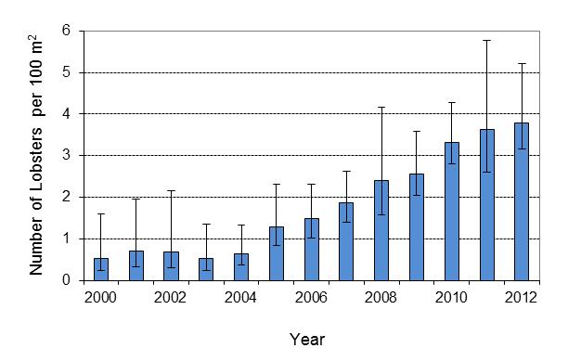

Figure 103. Standardized mean abundance (number of lobsters per 100 m2) from 2000 to 2012, averaged over sites and cohorts from a Bayesian estimation model. Also shown are 95% credibility intervals from MCMC sampling from the posterior distributions.

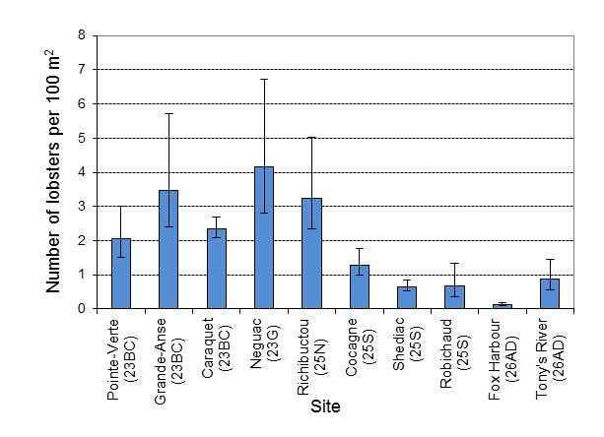

Figure 104. Standardized mean abundance (number of lobsters per 100 m²) by site, averaged over years and cohorts from the Bayesian estimation model. Also shown are 95% credibility intervals from the posterior distributions of the model fits.

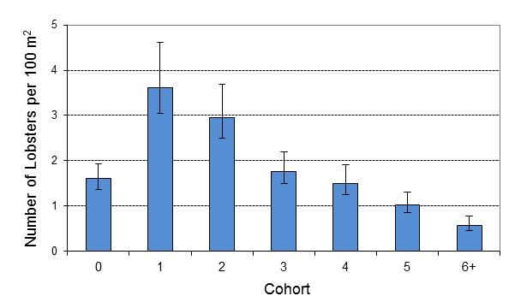

Figure 105. Standardized mean abundance (number of lobsters per 100 m²) by cohort, averaged over years and sites from a Bayesian estimation model. Also shown are 95% credibility intervals from MCMC sampling from the posterior distributions.

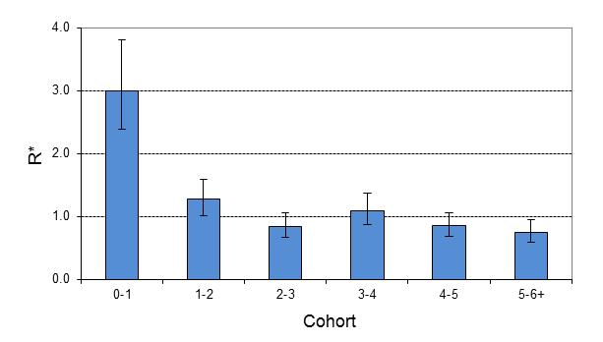

Figure 106. Ratios between cohorts (*R\**) by cohort, averaged over years and all sites. Also shown are 95% credibility intervals from MCMC sampling from the posterior distributions.

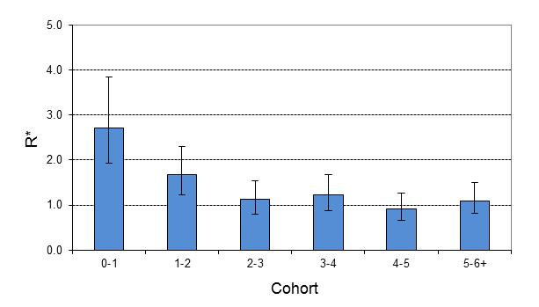

Figure 107. Ratios between cohorts (*R\**) by cohort, averaged over years and sites from central Northumberland Strait (i.e., sub-region 25S and 26AD). Also shown are 95% credibility intervals from MCMC sampling from the posterior distributions

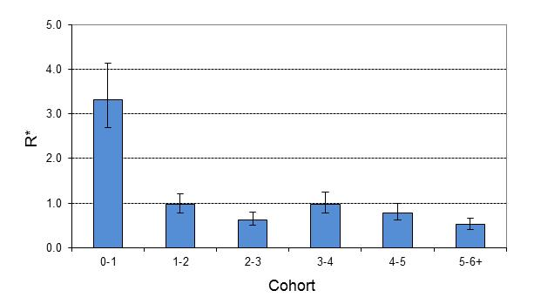

Figure 108. Ratios between cohorts (*R\**) by cohort, averaged over years and sites located in the Lobster Fishing Area 23 and sub-region 25N. Also shown are 95% credibility intervals from MCMC sampling from the posterior distributions

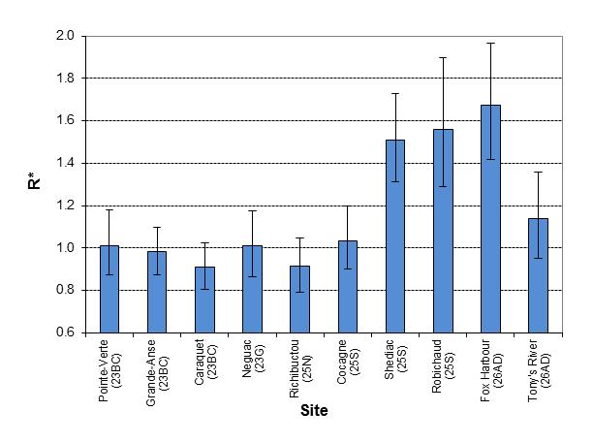

Figure 109. Ratios between cohorts (*R\**) by site, averaged over years and cohorts. Also shown are 95% credibility intervals from MCMC sampling from the posterior distributions.

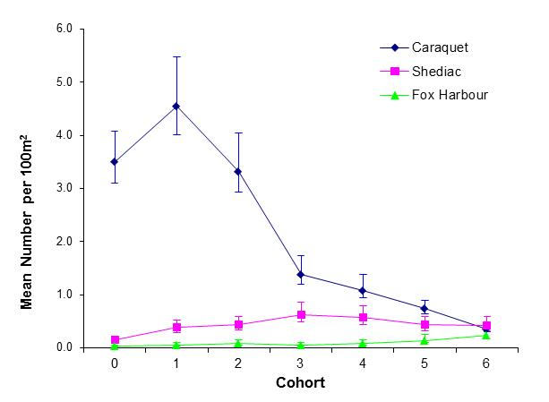

Figure 110. Standardized mean number of lobsters by cohort for Caraquet, Shediac and Fox Harbour from a Bayesian model. Also shown are 95% credibility intervals from MCMC sampling from the posterior distributions.

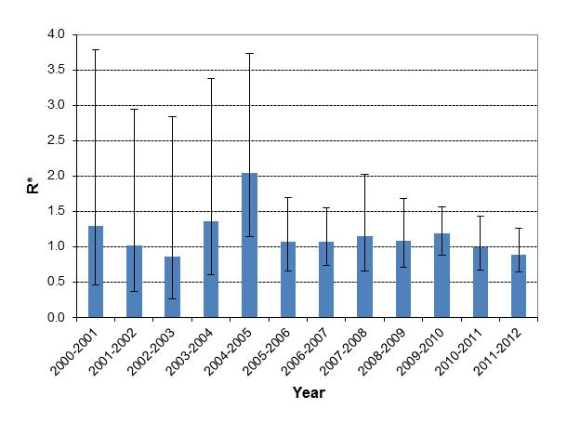

Figure 111. Ratios between cohorts (*R*)* by year, averaged over sites and cohorts. Also shown are 95% credibility intervals from MCMC sampling from the posterior distributions.

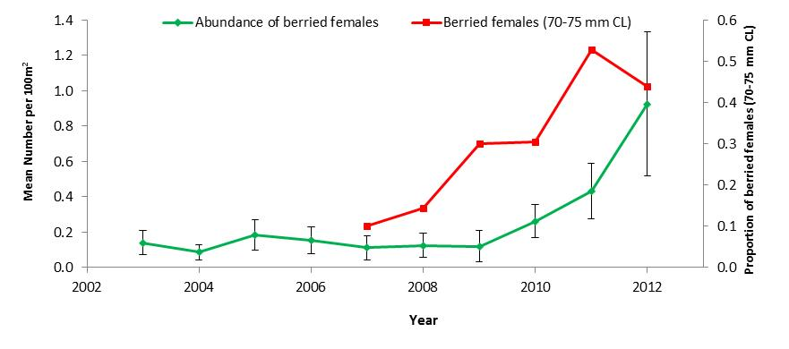

Figure 112. Empirical means for the abundance of berried females observed from SCUBA surveys in Caraquet between 2003 and 2012 showing an increase in egg production. The proportion of berried females ranging from 70 to 75 mm of carapace length (CL) between 2007 and 2012 is also shown. This size range represents the contribution to egg production related to the increase of the minimum legal size by 1 mm per year starting at 70 mm CL in 2007.

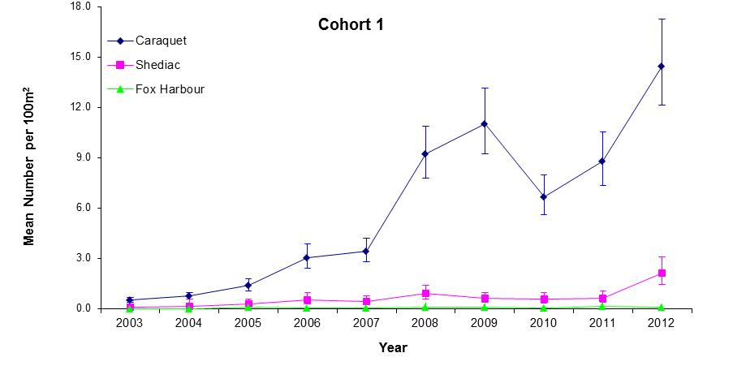

Figure 113. Standardized mean number of lobsters by year for cohort 1 for Caraquet, Shediac and Fox Harbour (from a Bayesian model). Also shown are 95% credibility intervals from MCMC sampling from the posterior distributions for the estimates from the Bayesian model.

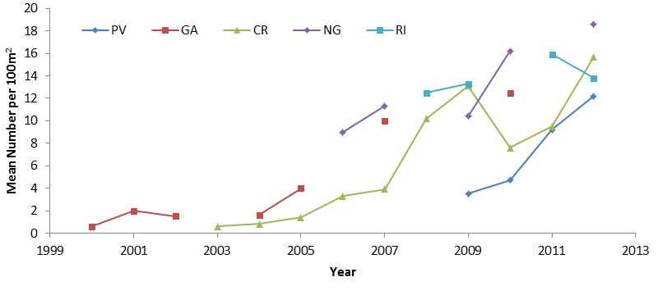

Figure 114. Empirical mean number of 1-year old lobsters based on SCUBA data for sites outside central Northumberland Strait from sub-region 23BC (Pointe-Verte; PV: Grande-Anse; GA: Caraquet; CR), sub-region 23G (Neguac; NG), and sub-region 25N (Richibucto; RI) .

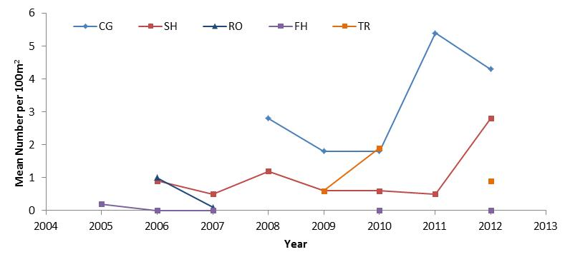

Figure 115. Empirical mean number of 1-year old lobsters based on SCUBA data for sites inside central Northumberland Strait from sub-region 25S (Cocagne; CG: Shediac; SH: Robichaud; RO), and sub-region 26ANS (Fox Harbour; FH: Toney River; TR).

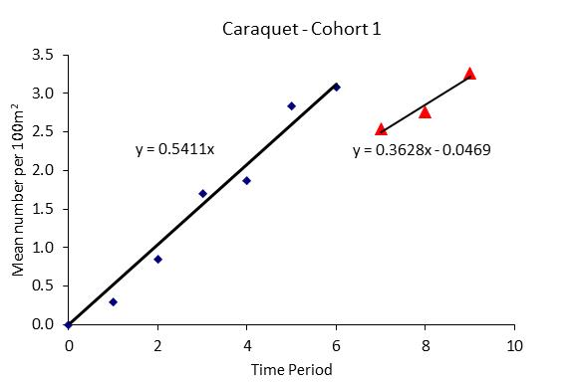

Figure 116. Empirical means for cohort 1 lobsters from SCUBA surveys carried out in Caraquet between 2003 and 2012 (time period 0-9) showing the significant increase in recruitment with a discontinuity between 2009 and 2010. Linear relationships of the logarithmically transformed densities as a function of time are presented.

Figure 39. Empirical mean number of young-of-year lobsters per square meter observed in various site in the southern Gulf of St. Lawrence between 2008 and 2012. AB=Alberton; AG=Arisaig; BD=Bedeque; CR=Caraquet; CV=Covehead; FO=Fortune; FOD=Fortune (22 m); MH=Murray Harbour; NG=Neguac; NM=Nine Mile Creek; SH=Shediac; SK=Skinner’s Pond.